PROJECT REPORT

On

### “Title of Project”

**Reddit Bot by using API in Python Programming**

***Submitted By***

**TANISHQ VIJAY SAKHARE**

***Guided By:-***

Mr. Ratnesh K. Choudhary



DEPARTMENT OF COMPUTER SCIENCE & ENGINEERING

**S. B. JAIN INSTITUTE OF TECHNOLOGY MANAGEMENT AND RESEARCH, NAGPUR.**

(An Autonomous Institute, Affiliated to RTMNU, Nagpur)

##### 2021-2022

**© S.B.J.I.T.M.R Nagpur 2022**

**S.B. JAIN INSTITUTE OF TECHNOLOGY MANAGEMENT AND RESEARCH, NAGPUR**

**DEPARTMENT OF COMPUTER SCIENCE & ENGINEERING**

SESSION 2021-2022

### CERTIFICATE

This is to certify that the Project titled **“Reddit Bot by using API in Python Programming”** is a bonafide work of **Tanishq Vijay Sakhare** carried out for the partial fulfillment of the requirement for the award of Degree of Bachelor of Engineering in **Computer Science & Engineering.**

|  |  |
| --- | --- |
| **Mr. Ratnesh K.**  **Choudhary**  Assistant Professor | **Mr. Animesh**  **Tayal**  Head of Department |

**INDEX**

|  |  |  |
| --- | --- | --- |
| CERTIFICATE |  | i |
| INDEX |  | ii |
| LIST OF FIGURES | | iii |
| CHAPTER 1 | INTRODUCTION | 1 |
| CHAPTER 2 | METHODOLOGY | 2-3 |
| CHAPTER 3 | TOOLS/PLATFORMS | 4 |
| CHAPTER 4 | DESIGN & IMPLEMENTATION | 5-8 |
|  | 4.1 ALGORITHM |  |
|  | 4.2 FLOWCHART |  |
|  | 4.3 SOURCE CODE |  |
| CHAPTER 5 | RESULT & DISCUSSION | 9-11 |
|  | 5.1 OUTPUT |  |
|  | 5.2 DISCUSSION |  |
|  | 5.3 APPLICATION |  |
| CHAPTER 6 | CONCLUSION | 12 |
|  | REFERENCES | 13 |

**LIST OF FIGURE**

|  |  |  |
| --- | --- | --- |
| **FIG. NO.** | **TITLE OF FIGURE** | **PAGE NO.** |
| 1.1 | REDDIT BOTS | 1 |
| 1.2 | CREATE AN APPLICATION IN REDDIT | 2 |
| 1.3 | TO DEVELOP AN APPLICATION IN REDDIT | 3 |
| 2.1 | FORMATE OF REDDIT BOT BY USING API | 4 |
| 4.2.1 | FLOWCHART (REDDIT BOT BY USING API) | 13 |
| 6.1 | REGISTRATION OF REDDIT BOT BY USING API | 26 |

# CHAPTER 1

## INTRODUCTION

#### Reddit Bot

A Reddit Bot is a program that can analyze comments, posts and others users actions respond them.

For e.g. You can create a Reddit Bot that scans all the comments in the community (r/funny), one of the largest subreddits.

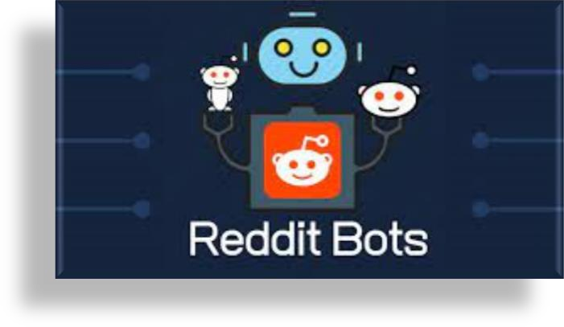

**FIG 1.1 REDDIT BOTS**

**Reddit Account:**

A Reddit account is required to access Reddit’s API. Create one at [Reddit](https://www.reddit.com/).

**Client ID & Client Secret:**

These two values are needed to access Reddit’s API as a script application (see Authenticating via OAuth for other application types). If you don’t already have a client ID and client secret, follow Reddit’s First Steps Guide to create them.

**User-Agent:**

A user agent is a unique identifier that helps Reddit determine the source of network requests. To use Reddit’s API, you need a unique and descriptive user agent. The recommended format is <platform>:<app ID>:<version string> (by u/<Reddit username>). For example, android:com.example.myredditapp:v1.2.3 (by u/kemitche). Read more about user agents at Reddit’s API wiki page.

#### Create an Application while using Reddit.

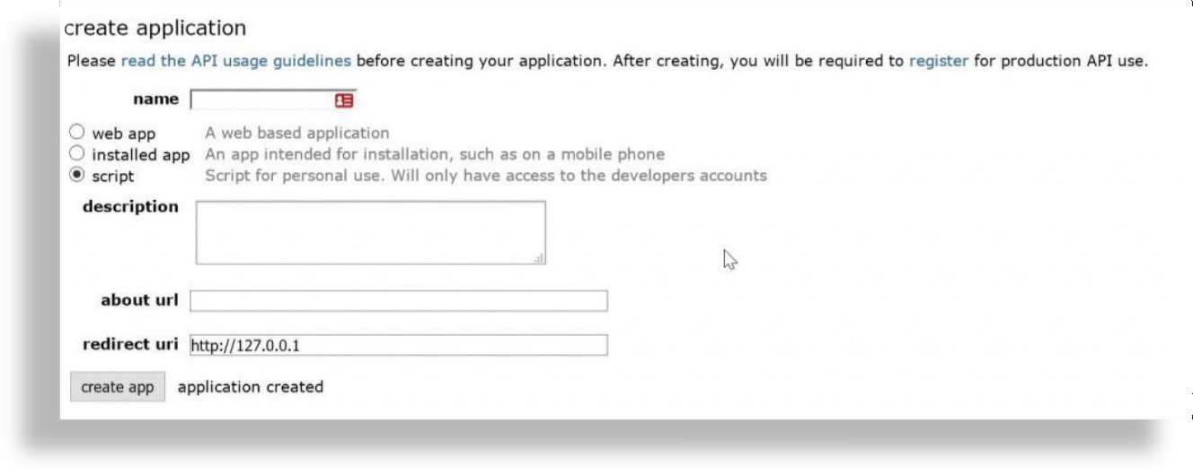

**FIG 1.2 CREATE AN APPLICATION IN REDDIT**

I want to build this project i.e. **“Reddit Bot by using API in Python Programming”**, we use

some applications like various tools of that particular packages in python. Now, I build that

program so following perform actions :

* First, we have to download python in update/ latest version.
* Then, we have to install python in “praw” package i.e. ( pip install praw ) .
* So, ready for that package now you have to check and run IDLE (import praw) .
* To run this python program on VS Code.

#### To Develop Application in Reddit.

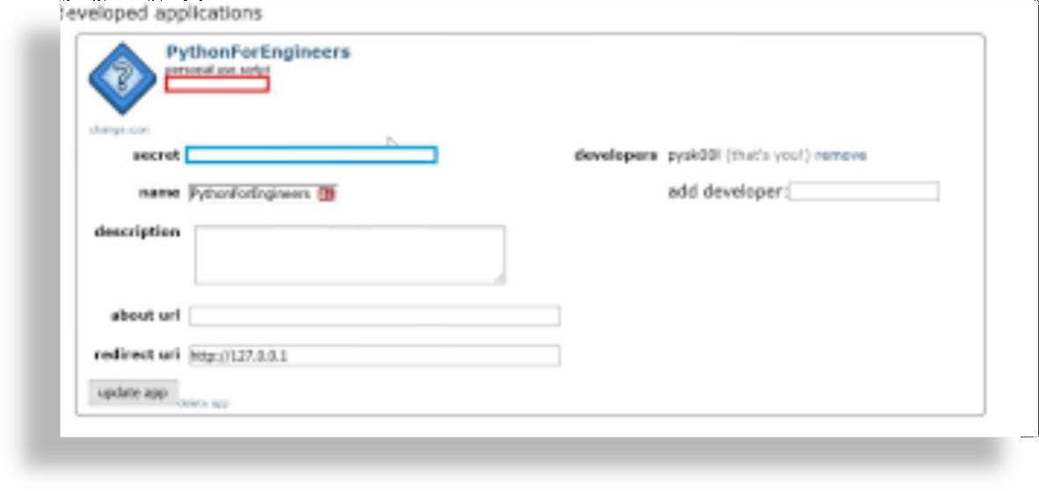

**FIG 1.3 TO DEVELOP AN APPLICATION IN REDDIT**

# CHAPTER 2

## METHODOLOGY

#### Methodology (Reddit Bot by using API in Python Programminmg) .

Now, to import praw and next to initialize values like Client id, Client secret, username, password and user agent. So, we have to create reddit instance (praw.Reddit) then find topmost submission in subreddit (reddit.subreddit). By using for loop conditions of that particular displays the title, score, id and url and then print them. Comment on known submission (reddit.submission), Similarly comment on id (reddit.comment) and then print them score before and after downvoting.

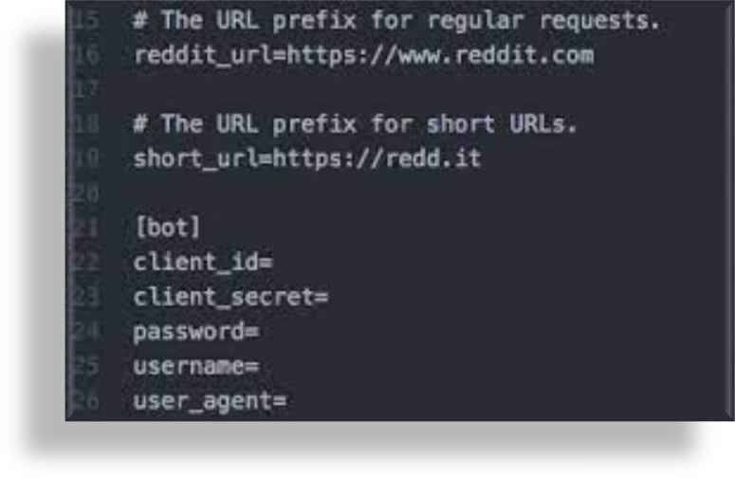

**FIG 2.1 FORMATE OF REDDIT BOT BY USING API**

# CHAPTER 3

## TOOLS/PLATFORMS

A collection of tools that utilize PRAW. Two current tools are modutils a program useful to subreddit moderators,

and subreddit_stats , a tool to compute submission / comment statistics for a subreddit.

[**r.doqdo**](https://bitbucket.org/john2x/rdoqdoq)**q**

A website that displays reddit stories under the guise of Python or Java code.

[**reddit Notifier**](https://github.com/nemec/reddit-notify)

Integrates with Unity and Gnome Shell to display new reddit mail as it arrives.

[**Link Unscripter**](https://github.com/sparr/reddit-link-unscripter)

A bot for replying to posts <and comments, eventually> that contain javascript-required links to provide non-javascript alternatives.

Examines a redditor’s posting history and creates [a comment](http://www.reddit.com/r/AskReddit/comments/129lyb/what_fact_about_reality_terrifies_you_or_gives/c6tbgd7?context=1) [with a nice activity overview](http://www.reddit.com/r/AskReddit/comments/129lyb/what_fact_about_reality_terrifies_you_or_gives/c6tbgd7?context=1). ClockStalker uses an older version of PRAW, the reddit , module. It should, but may not,

work with the latest version of PRAW.

[**ClockStalker**](https://github.com/ClockStalker/clockstalker)

[**Butcher bot**](https://github.com/xiphirx/Butcher-Bot)

Handles routine tasks on [r/Diablo](http://www.reddit.com/r/diablo) such as the removal of

images/memes and bandwagon-esque titles.

[**r/diablo flair infographic generator**](https://github.com/xiphirx/rdiablo-flair-infographic-generator)

Creates beautiful [infographics](http://i.imgur.com/smqWx.jpg).

[**Groompbot**](https://github.com/AndrewNeo/groompbot) **by** [**u/AndrewNeo**](http://www.reddit.com/user/AndrewNeo)

Posts new videos from YouTube to a subreddit.

[**newsfrbot**](https://github.com/gardaud/newsfrbot)

Parses RSS feeds from some major french publications and

posts them to relevant subreddits.

[**reddit-modbot**](https://github.com/rasher/reddit-modbot)

A relatively lightweight script for automating reddit moderating tasks. It was written as a simpler alternative

to [AutoModerator](https://github.com/Deimos/AutoModerator) by Deimos.

[**reddit-giveaway-bot**](https://github.com/nemec/reddit-giveaway-bot)

A bot that automatically manages giveaway. One feature gives out product keys to the first N commenters.

[**DailyProgBot**](https://github.com/nint22/DailyProgBot)

A simple challenge-queue submission bot

for [r/DailyProgrammer](http://www.reddit.com/r/Dailyprogrammer). Users submit challenges through a Google Documents form, then the bot crawls said form, posting the appropriate challenge on the appropriate day of the week.

[**VideoLinkBo**](https://github.com/dmarx/VideoLinkBot)**t**

A bot that aggregates video links in a response comment where multiple videos links appear in reply to a submission (uses a slightly out-of-date version of PRAW, currently

requires Submission.all_comments_flat ).

[**reddit-analysis**](https://github.com/rhiever/reddit-analysis)

Scrapes a specific subreddit or user and prints out all of the commonly-used words in the past month. Contains a data file containing a list of words that should be considered common.

[**AlienFeed**](https://github.com/jawerty/AlienFeed)

AlienFeed is a command line application made for displaying and interacting with reddit submissions. The client can return a list containing the top submissions in a subreddit, and even

open the links up if you’d like.

[**ALTcointip**](https://github.com/vindimy/altcointip)

ALTcointip bot allows redditors to gift (tip) various cryptocoins (Litecoin, PPCoin, Namecoin, etc) to each other as a way of saying thanks.

[**RedditAgain**](https://github.com/karan/RedditAgain)

Migrate an old reddit account to a new one. Backs up existing content and submissions, and copies subscriptions to a new account.

[**reddit-cloud**](https://github.com/paul-nechifor/reddit-cloud)

Generates word clouds for submissions (or users), posts them to Imgur and the URL to reddit. It’s what I run

on [u/WordCloudBot2](http://www.reddit.com/user/WordCloudBot2).

[**Reddit-to-Diigo-Copier**](https://github.com/OdinsHat/Reddit-to-Diigo-Copier)

Copies your reddit saved links to a Diigo account of your choice. Makes use of PRAW and the Diigo API.

##### [NetflixBot](https://github.com/alanwright/netflixbot)

Parses comments for calls and determines if a movie is availble for streaming on Netflix. Makes use of PRAW and the NetflixRouletteAPI. Run on [u/NetflixBot](http://www.reddit.com/user/NetflixBot).

##### [RemindMeBot](https://github.com/SIlver--/remindmebot-reddit)

Called upon with the

command on any

RemindMeBot!

subreddit, the user is able to set a reminder for themselves about the current thread or comment. The bot will then send them a private message with the date they

specified. [u/RemindMeBot](http://www.reddit.com/user/RemindMeBot).

[**RedditRover**](https://github.com/DarkMio/RedditRover)

A plugin based Reddit Multi Bot Framework intended for new and advanced programmers to host a wide variety of Reddit bots without mangling with all the ins and outs of Reddit, PRAW and API limitations.

[**Reddit Keyword Tracking Bot**](https://github.com/SwedishBotMafia/RScanBot.Gen)

<requires Kivy> A bot that will watch any subreddits and email you with updates when it finds words that matter to you. settings are configured via a GUI making it easy for people who don’t know how to edit python scripts.

[**Reddit-Paper**](https://github.com/cameron-gagnon/reddit-paper)

Command line interface program that will download the top 5 images from r/earthporn, r/spaceporn, etc. and set them as the computer’s wallpaper. Currently only tested and used on Ubuntu, but more OS’s coming soon.

[**QR Codify**](https://github.com/JstnPwll/QRCodify)

Fetches username mentions and converts the comment data into a QR code. The code is then posted via ASCII characters as a followup comment.

[**EVE Killmail Reddit Bot**](https://github.com/ArnoldM904/EK_Reddit_Bot)

Searches for comments in /r/eve that contain zkillboard killmail links. Then replies to comments with web-scraped TL;DR of the information.

[**ButtsBot**](https://github.com/jadunawa/ButtsBot)

A silly bot that posts a picture of a (clothed) butt from the Astros team whenever somebody in the /r/Astros subreddit uses any of a few certain keywords in a comment.

[**GoodReads Bot**](https://github.com/avinassh/Reddit-GoodReads-Bot)

A bot which powers [/u/goodreadsbot](https://www.reddit.com/u/goodreadsbot) on Reddit, posts information of a book whenever someone posts a link to Goodreads.

[**Self-Destruct Bot**](https://github.com/diceroll123/SelfDestructBot)

Removes posts after a specified amount of time. (For time- sensitive posts.)

[**Subtitle Bot**](https://github.com/arrayofchar/reddit_subtitle_bot)

Finds youtube links and see if closed captioning (aka subtitle) is available. Formats subtitle into paragraphs based on standard deviation of timestamp gaps. If subtitle is longer than Reddit comment limit, puts it in Pastebin.

[**Reddit Countdown**](https://github.com/matchu/reddit-countdown)

Implements a countdown in a subreddit’s sidebar to help Reddit communities count down to important events.

[**chattR**](https://github.com/patrickstocklin/chattr)

Quantitatively analyzes the sophistication-level and polarity/subjectivity of conversation in a subreddit using the Flesch-Kincaid Reading Level Algorithm.

# CHAPTER 4

## DESIGN & IMPLEMENTATION

* 1. **ALGORITHM**

Step 1: Start the program.

Step 2: First, we need to download python on latest version.

Step 3: Then, we have to install “praw” package by using pip command ( pip install praw) .

Step 4: Now, initialize the values like client id, client secret, username, password and user agent.

Step 5: To create an authorized reddit instance (praw.Reddit) .

Step 6: We need to find topmost submission in subreddit (reddit.subreddit) .

Step 7: According to for loop conditions we have to displays the titles, score, id and url.

Step 8: Print them on particular displays.

Step 9: Now, comment on known submission (reddit.submission) . Step 10: Then, comment on id (reddit.comment) .

Step 12: Lastly, print them score before and after downvoting. Step 13: Stop.

Start

import praw

“Install praw package by using pip command”

init values like id, secret, username, password and user

praw.Reddit

Create Reddit instance

reddit.subreddit

Find topmost submission in subreddit

* 1. **FLOWCHART**

Print them

Displays the title, score, id and url

Comment on id

Comment on known submission

reddit.comment

Using for

Stop

Print them score before and after downvoting

reddit.submission

**FIG 4.2.1 FLOWCHART**

* 1. **SOURCE CODE**

# importing the module import praw

# initialize with appropriate values client_id = ""

client_secret = "" username = "" password = "" user_agent = ""

# creating an authorized reddit instance

reddit = praw.Reddit(client_id = "qm9HMn3ZmWASDuqY2HrxOA", client_secret = "935gjE5RvEwxNI371o6tQt1BEkbtAQ", username = "Sak-Tanishq0910",

password = "tanishq@0910",

user_agent = '<console:name:version (by /u/Sak-Tanishq0910)>')

# to find the top most submission in the subreddit "Programmer" subreddit = reddit.subreddit('Programmer')

for submission in subreddit.top(limit = 25): # displays the submission title print(submission.title)

# displays the net upvotes of the submission print(submission.score)

# displays the submission's ID print(submission.id)

# displays the url of the submission print(submission.url)

# Comment on a known submission

submission = reddit.submission(url="https://[www.reddit.com/comments/5e1az9](http://www.reddit.com/comments/5e1az9)") submission.reply("Good")

# the ID of the comment comment_id = "fvib7aw"

# instantiating the Comment class comment = reddit.comment(comment_id)

comment = reddit.comment(comment_id)

print("Score before downvoting : " + str(comment.score)) # downvoting the comment

comment.downvote()

print("Score after downvoting : " + str(comment.score))

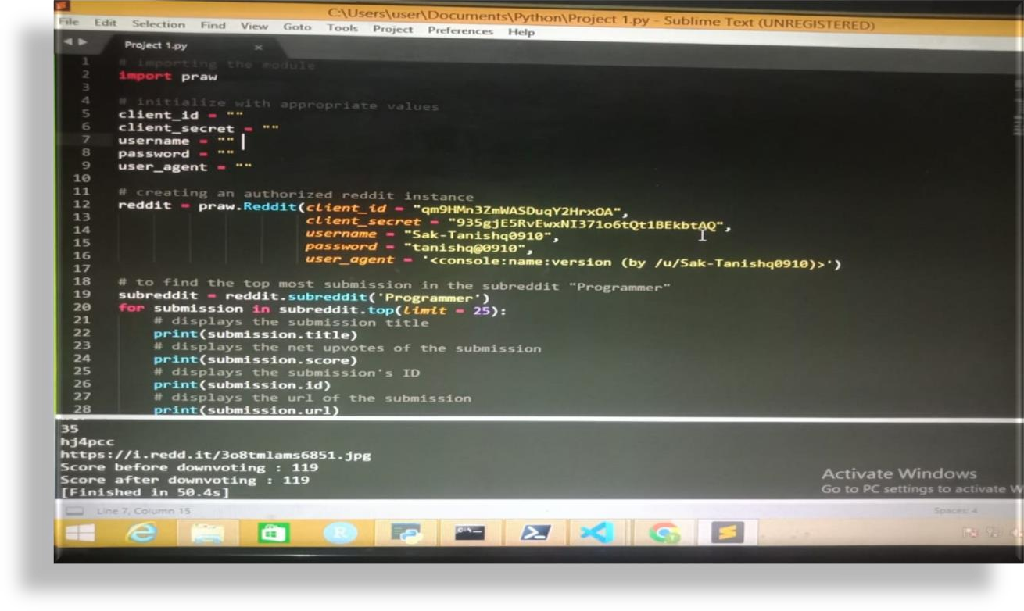

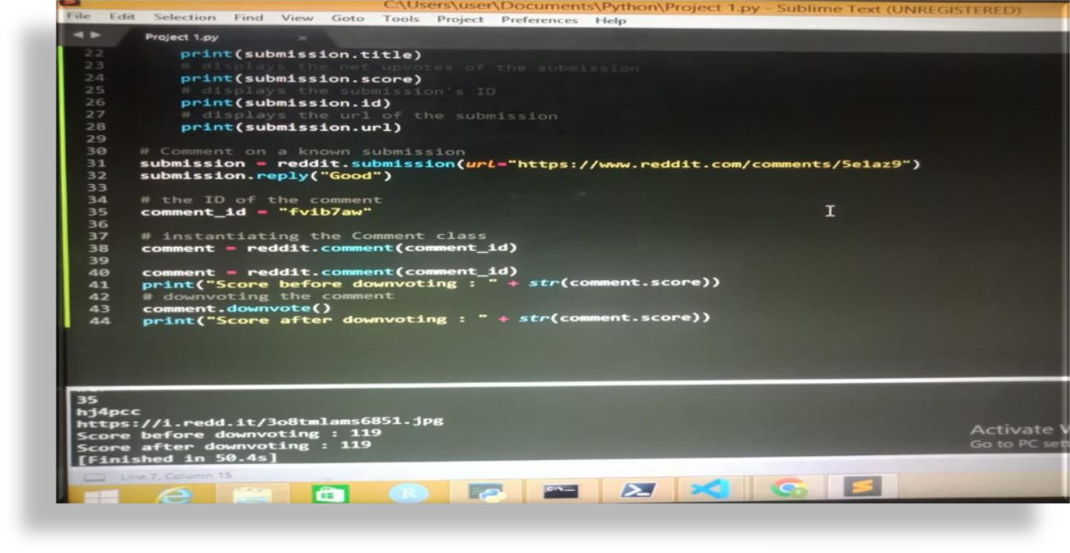

# CHAPTER 5

## RESULT & DISCUSSION

* 1. **OUTPUT**

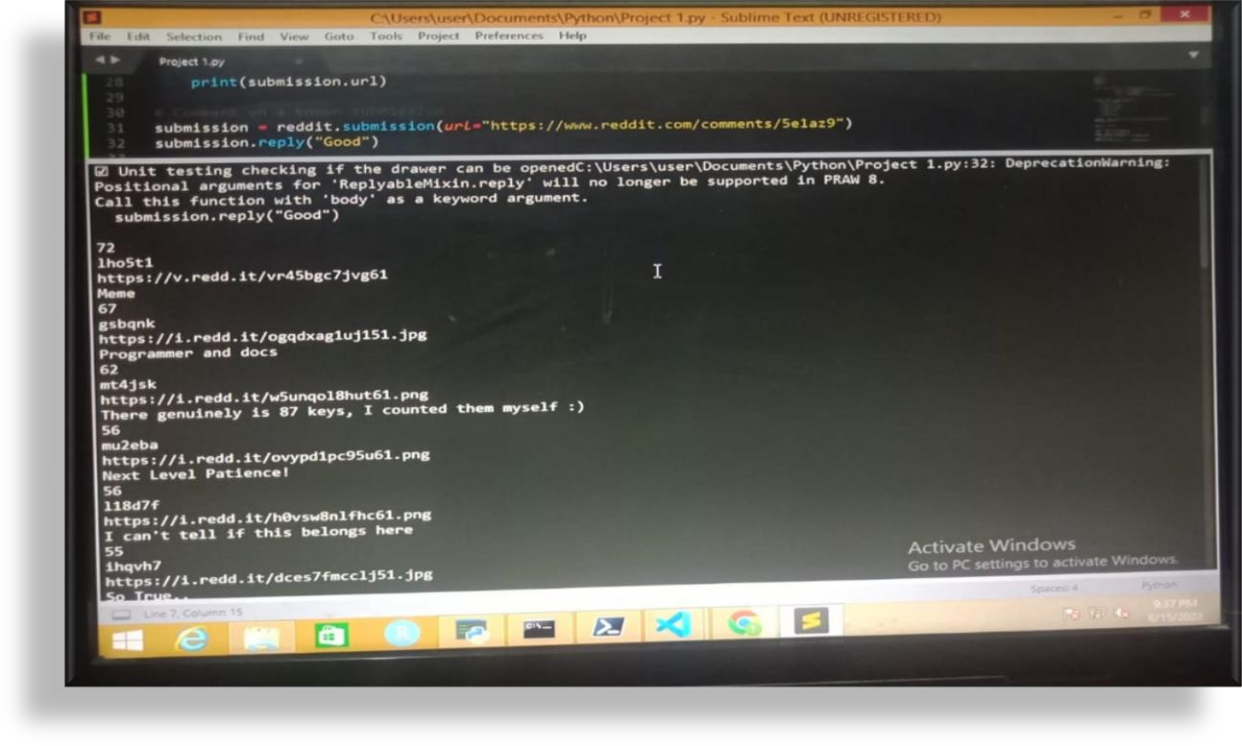

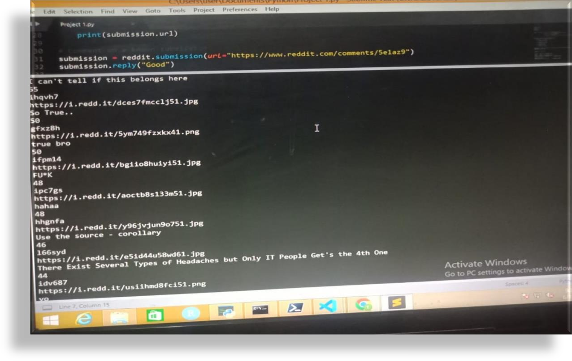

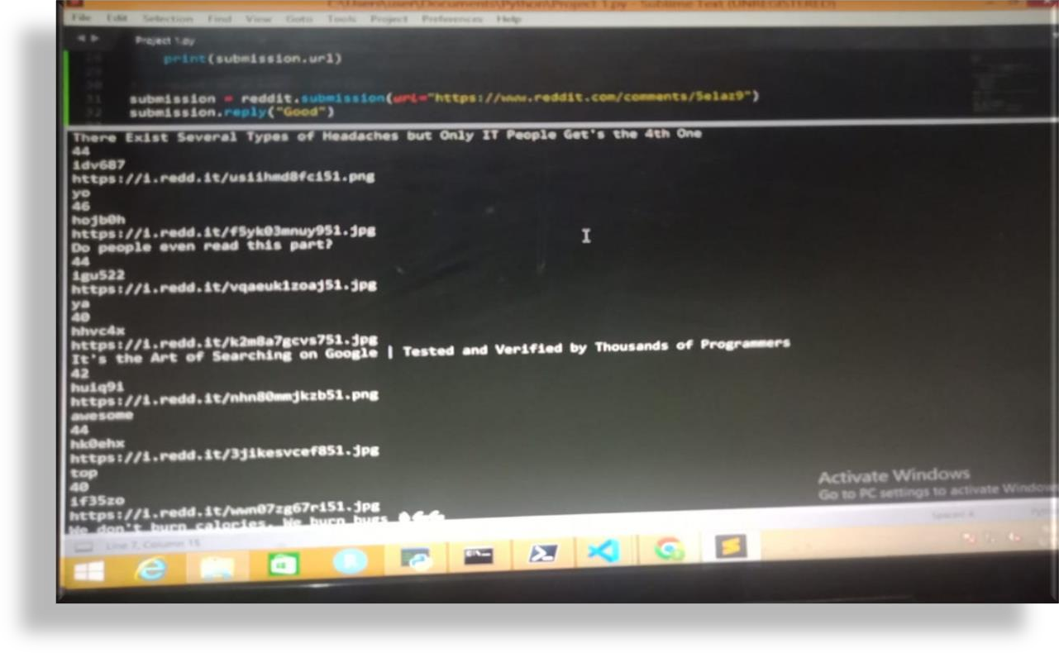

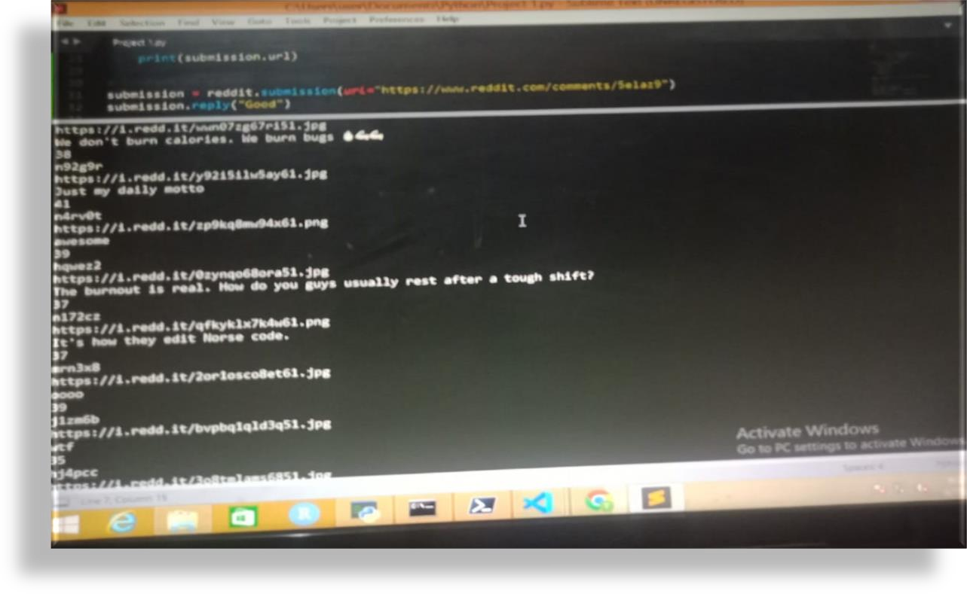

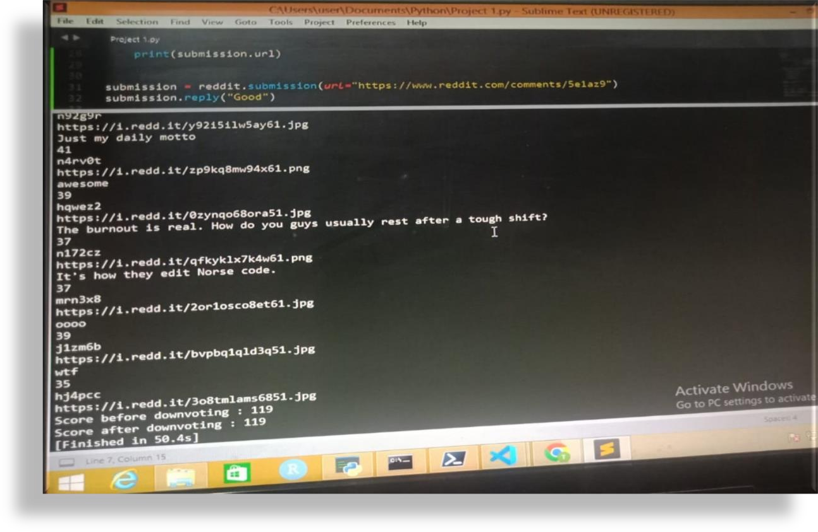

* 1. **DISCUSSION**

Reddit is one of the biggest social news aggregation in United states. All the members can post about anything in related [subreddit](https://www.reddit.com/subreddits/). If you are having a product which lots of people are using then getting to know what they are feeling about the product is really important. Social media platforms like facebook, Twitter, reddit etc. are one of the most widely used by people. Reddit is also a discussion forum where people can talk and discuss about anything. Almost all products whether its microsoft Azure or AWS are having their subreddits on which they communicate with their users. So, What if you want to know about the sentiments of users and get all the negative headlines from a subreddit so that you can improve the product accordingly or if you want to interact with user in real time. Here I will be explaining that how you can get notification in slack with the URL link of the headlines if any user is starting a negative discussion about a product related to you in real time.

Lets start …

1. First we need few details like below which can be created by going on twitter and follow the instruction

on <https://redditclient.readthedocs.io/en/latest/oauth/>

you can use your own reddit account for that there is not need of using official vivox account and i am not aware if we even have any official reddit account or not.

**client_id**=’client_id’, \

**client_secret**=’client_secret’, \

**user_agent**=’user_agent’, \ **username**=’username’, \ **password**=’password’

1. we need some libraries to set up the whole process. So, please install the below libraries into your environment:-

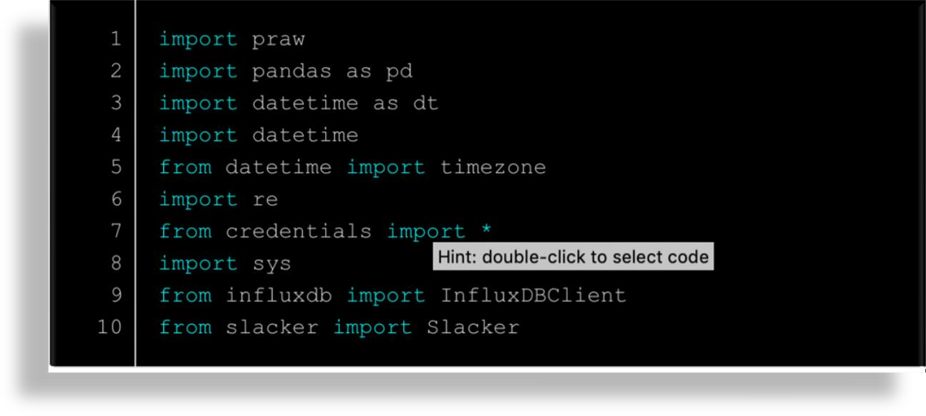

1. After that we will setup setup the reddit with praw method as praw is the api to interact with reddit data. if you want to read more about praw please go here <https://praw.readthedocs.io/en/latest/>.

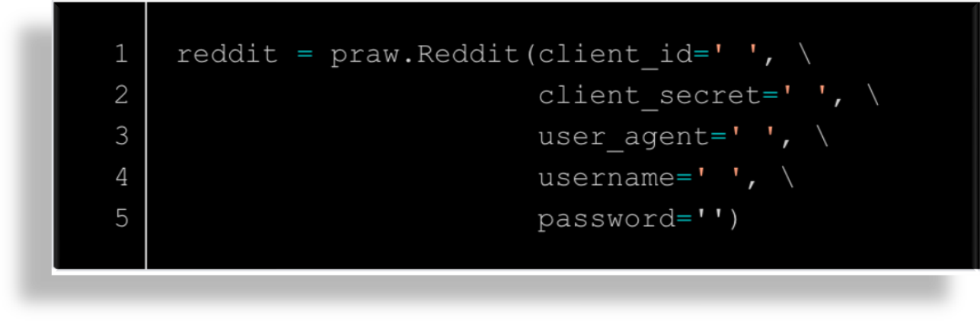

* 1. **APPLICATION**

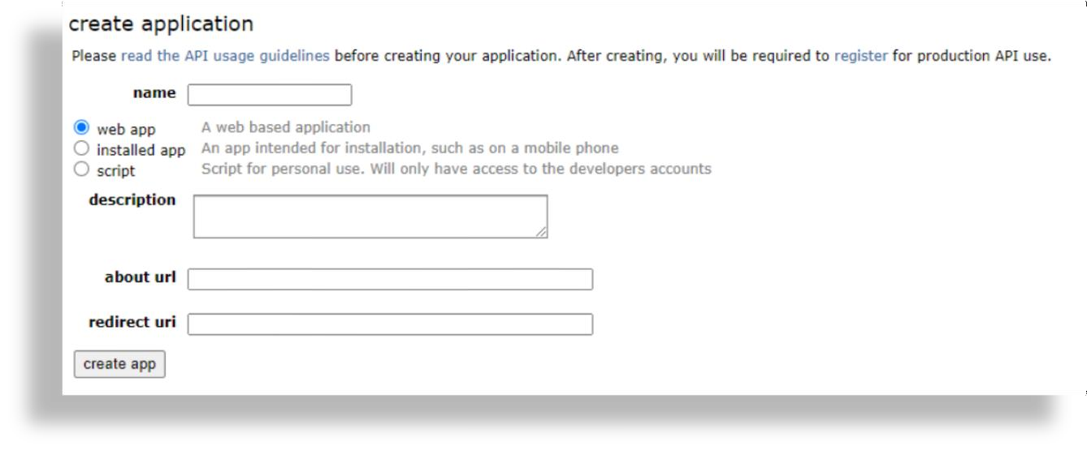

Create an application

Go to Reddit and [create application](https://www.reddit.com/prefs/apps):

* Type name for your application and select “script” option.
* In ‘redirect uri’ type any random link.
* Click the “Create app” button.

Take a look at the “Personal Use Script” and “Secret”. Note them, we will need this data in next steps.

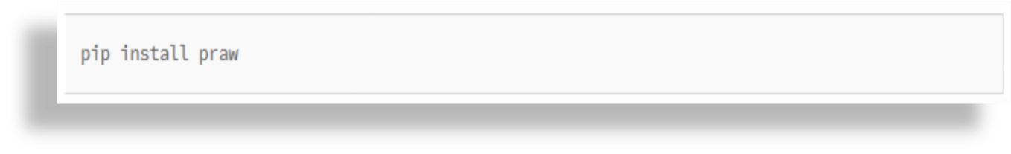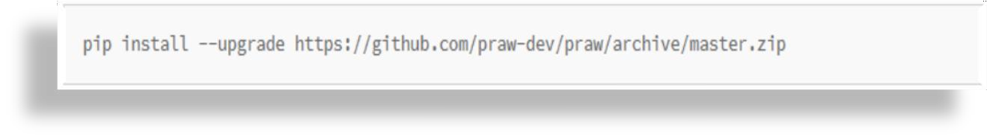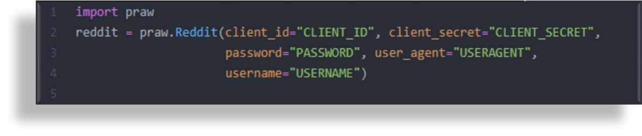

Write Python code for our Bot

Next we need to download a library for Python by pip manager – Python Reddit API Wrapper.

Type “pip install praw”.

Or install the latest version:

*Note: The Reddit API* [*has*](https://pythonprogramming.net/introduction-python-reddit-api-wrapper-praw-tutorial/) *a rate limit of 30 requests per minute, but you can still make quite a bit with this. The PRAW also dynamically handles the rate limiting for you and attempts to be efficient, so you won’t have to worry about crossing the line, but you might wonder regardless why things might not be going as quick as you expect.*

To instantiate an instance of PRAW:

*import praw*

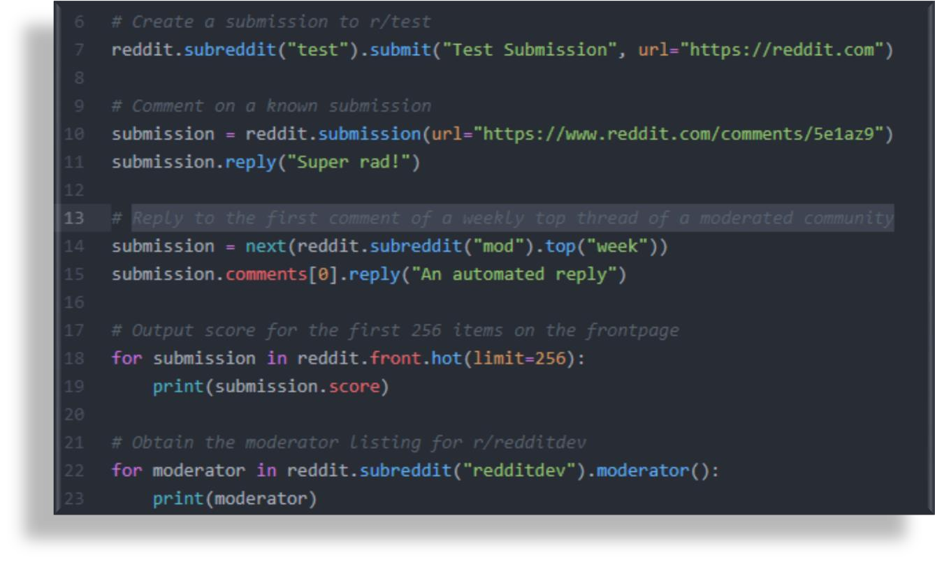

*reddit = praw.Reddit(client_id=”CLIENT_ID”, client_secret=”CLIENT_SECRET”,*

*password=”PASSWORD”, user_agent=”USERAGENT”, username=”USERNAME”)*

With the reddit instance you can then interact with Reddit by different ways:

*# Create a submission to r/test*

*reddit.subreddit(“test”).submit(“Test Submission”, url=”https://reddit.com”)*

*# Comment on a known submission submission =*

*reddit.submission(url=”http*[*s://www.reddit.com/comments/5e1az9*](http://www.reddit.com/comments/5e1az9)*″) submission.reply(“Super rad!”)*

*# Reply to the first comment of a weekly top thread of a moderated community*

*submission = next(reddit.subreddit(“mod”).top(“week”)) submission.comments[0].reply(“An automated reply”)*

*# Output score for the first 256 items on the frontpage for submission in reddit.front.hot(limit=256):*

*print(submission.score)*

# CHAPTER 6

## CONCLUSION

We have designed and developed a Reddit Bot by using API in Python Programming which provides an information of that particular sector.

We have used modern tools like Arduino IDLE and hardware components like

Some pakackages like “praw” and install through pip command.

During the development of the project we have applied professional ethics and we understood the importance of individual while project management. While showcasing our project through various seminars ,we enhanced our communication skills and displayed professional ethics which results in lifelong learning.

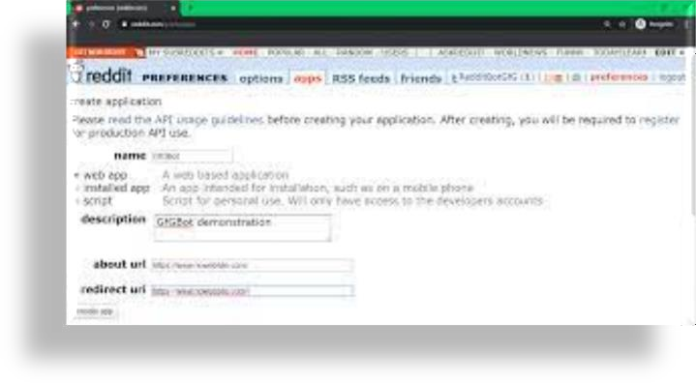

**FIG 6.1 REGISTRATION OF REDDIT BOT BY USING API**

### REFERENCE

* [**https://www.reddit.com/**](https://www.reddit.com/)
* [**https://levelup.gitconnected.com/creating-a-reddit-bot-**](https://levelup.gitconnected.com/creating-a-reddit-bot-using-python-5464d4a5dff2)[**using-python-5464d4a5dff2**](https://levelup.gitconnected.com/creating-a-reddit-bot-using-python-5464d4a5dff2)
* [**https://www.reddit.com/prefs/apps/**](https://www.reddit.com/prefs/apps/)

## Notes:

1. **Chapter Title –** Front size = 16, Front Type = Times New Roman, Alignment = Centered,

Bold.

(Example – INTRODUCTION)

1. **Heading –** Front size = 14, Front Type = Times New Roman, Alignment = Left, Bold.

(Example – 4.1 ALGORITHM)

1. **Sub Heading -** Front size = 12, Front Type = Times New Roman, Alignment = Left, Bold.

(Example – Module)

1. **Content -** Front size = 12, Front Type = Times New Roman, Alignment = Left.

(Example – Write down proper information about you project)

1. **Figure –** Give proper name to your figure and screenshot.

Front size = 12, Front Type = Times New Roman, Alignment

= Centered.

Fig. Chapter no. name of figure/screenshot (Example – Fig. 4 Flowchart of Tic-Tac-Toe)